Name: Umamah Binti Aziz
SAP ID: 72012
Dept: BSCY-03
COAL LAB
LAB 11 TASKS
Task 01
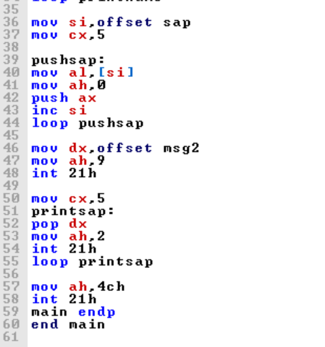
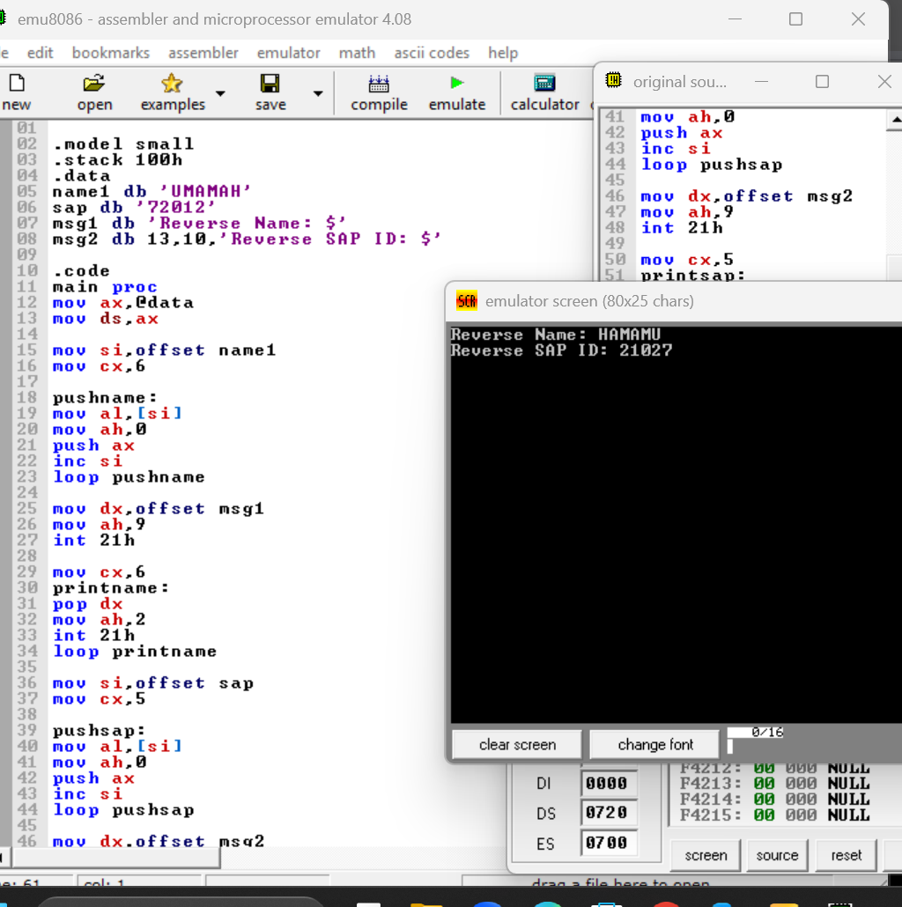

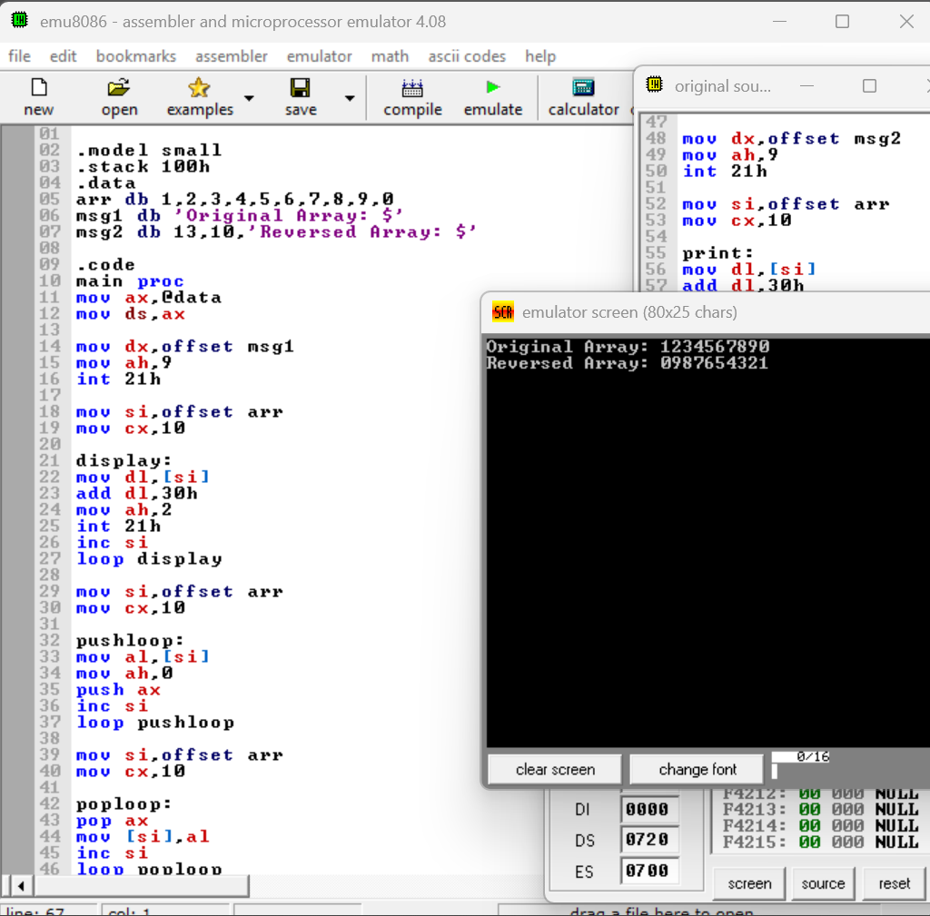
Task 02



